LAB 1: Introduction to Networking

Contents

How to use the Lab Guides 2

Introduction to LAB 1 2

Exercise 1: Download and install Cisco Packet Tracer 2

# How to use the Lab Guides

The lab guides in this training are designed to be completed in class or at home. This means that depending on your time and availability, you can accomplish the tasks in each lab either after the corresponding module, use it as a homework or split it for class/home work as you wish. Important is that you are finished with each lab before the date of the next module.

# Introduction to LAB 1

In this first LAB, you will be asked to download and install Cisco Packet Tracer and to spend some time learning how to use it. This simulator will be your primary tool for practicing with network configuration commands, protocols and configurations.

# Exercise 1: Download and install Cisco Packet Tracer

In this task you are going to do the following:

* Register an account at <https://www.netacad.com>
* Watch the online course to learn how to work with it
* Download and install the **Cisco Packet Tracer** simulator on your computer

1. Navigate to <https://www.netacad.com/courses/packet-tracer>
2. Scroll down to **Enroll to download Packet Tracer** and click on it
3. Click on **Sign up today!** Button and select **English**
4. Fill the information under the Sign Up For Introduction to Packet Tracer 0918 section and click on **Create Account**
5. Click **Launch Course** in the popup window

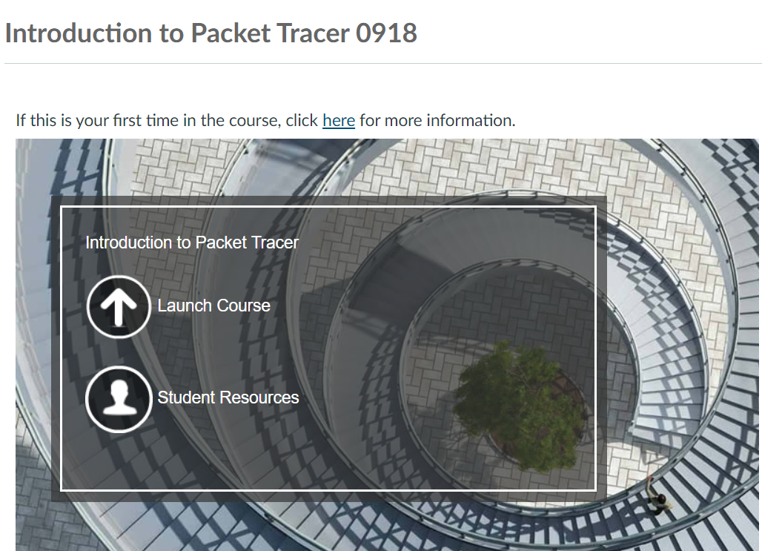

1. Follow the **Introduction to Packet Tracer** course to learn the basic concepts
2. Go to **Student Resources** to download Cisco Packet Tracer
3. Click on **Download and install the latest version of Packet Tracer**

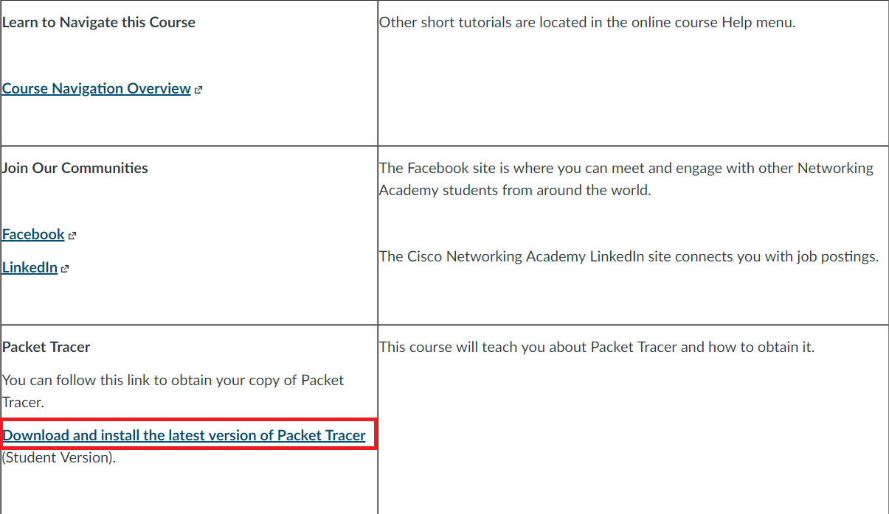

1. Select the latest version (currently this is Cisco Packet Tracer 7.2)

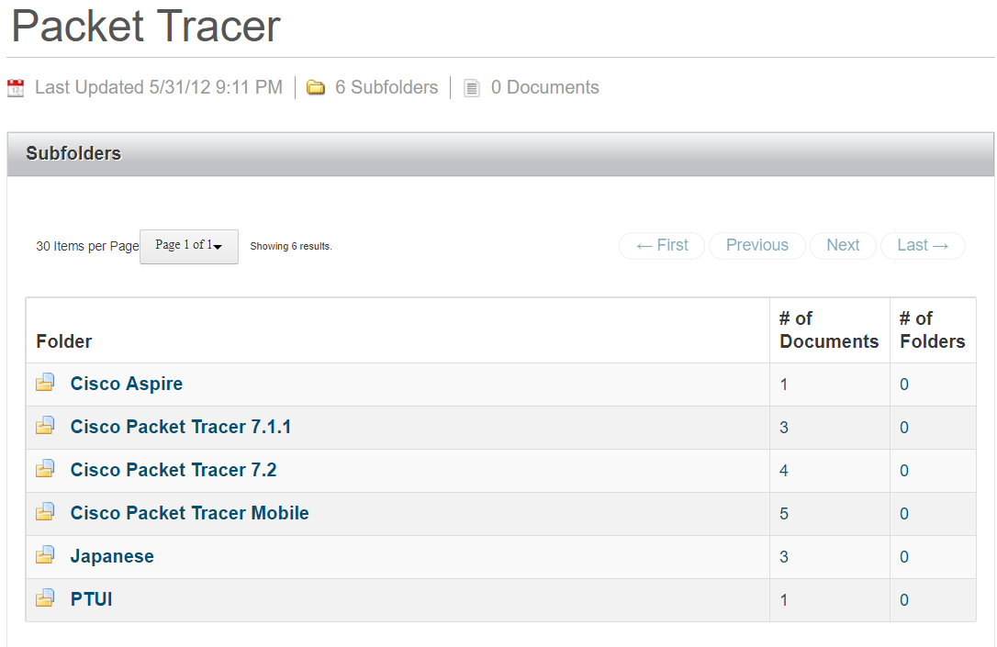

1. Select your platform to start downloading it

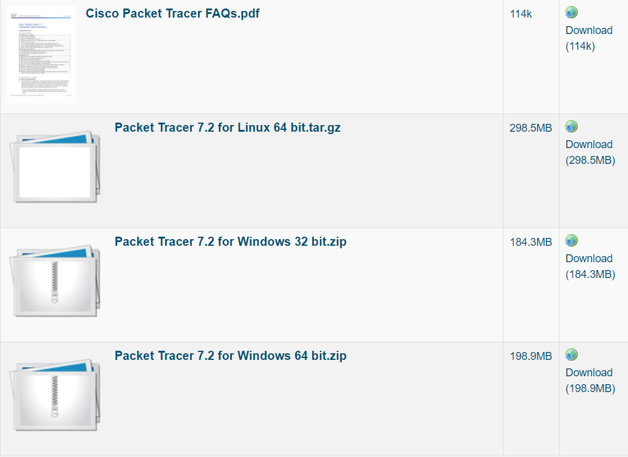

1. Extract the package and install it. Then, login with your credentials
2. You should now have installed and logged in to **Cisco Packet Tracer**

Please have a look around and play with it by adding devices and connecting them

You have completed LAB 1.